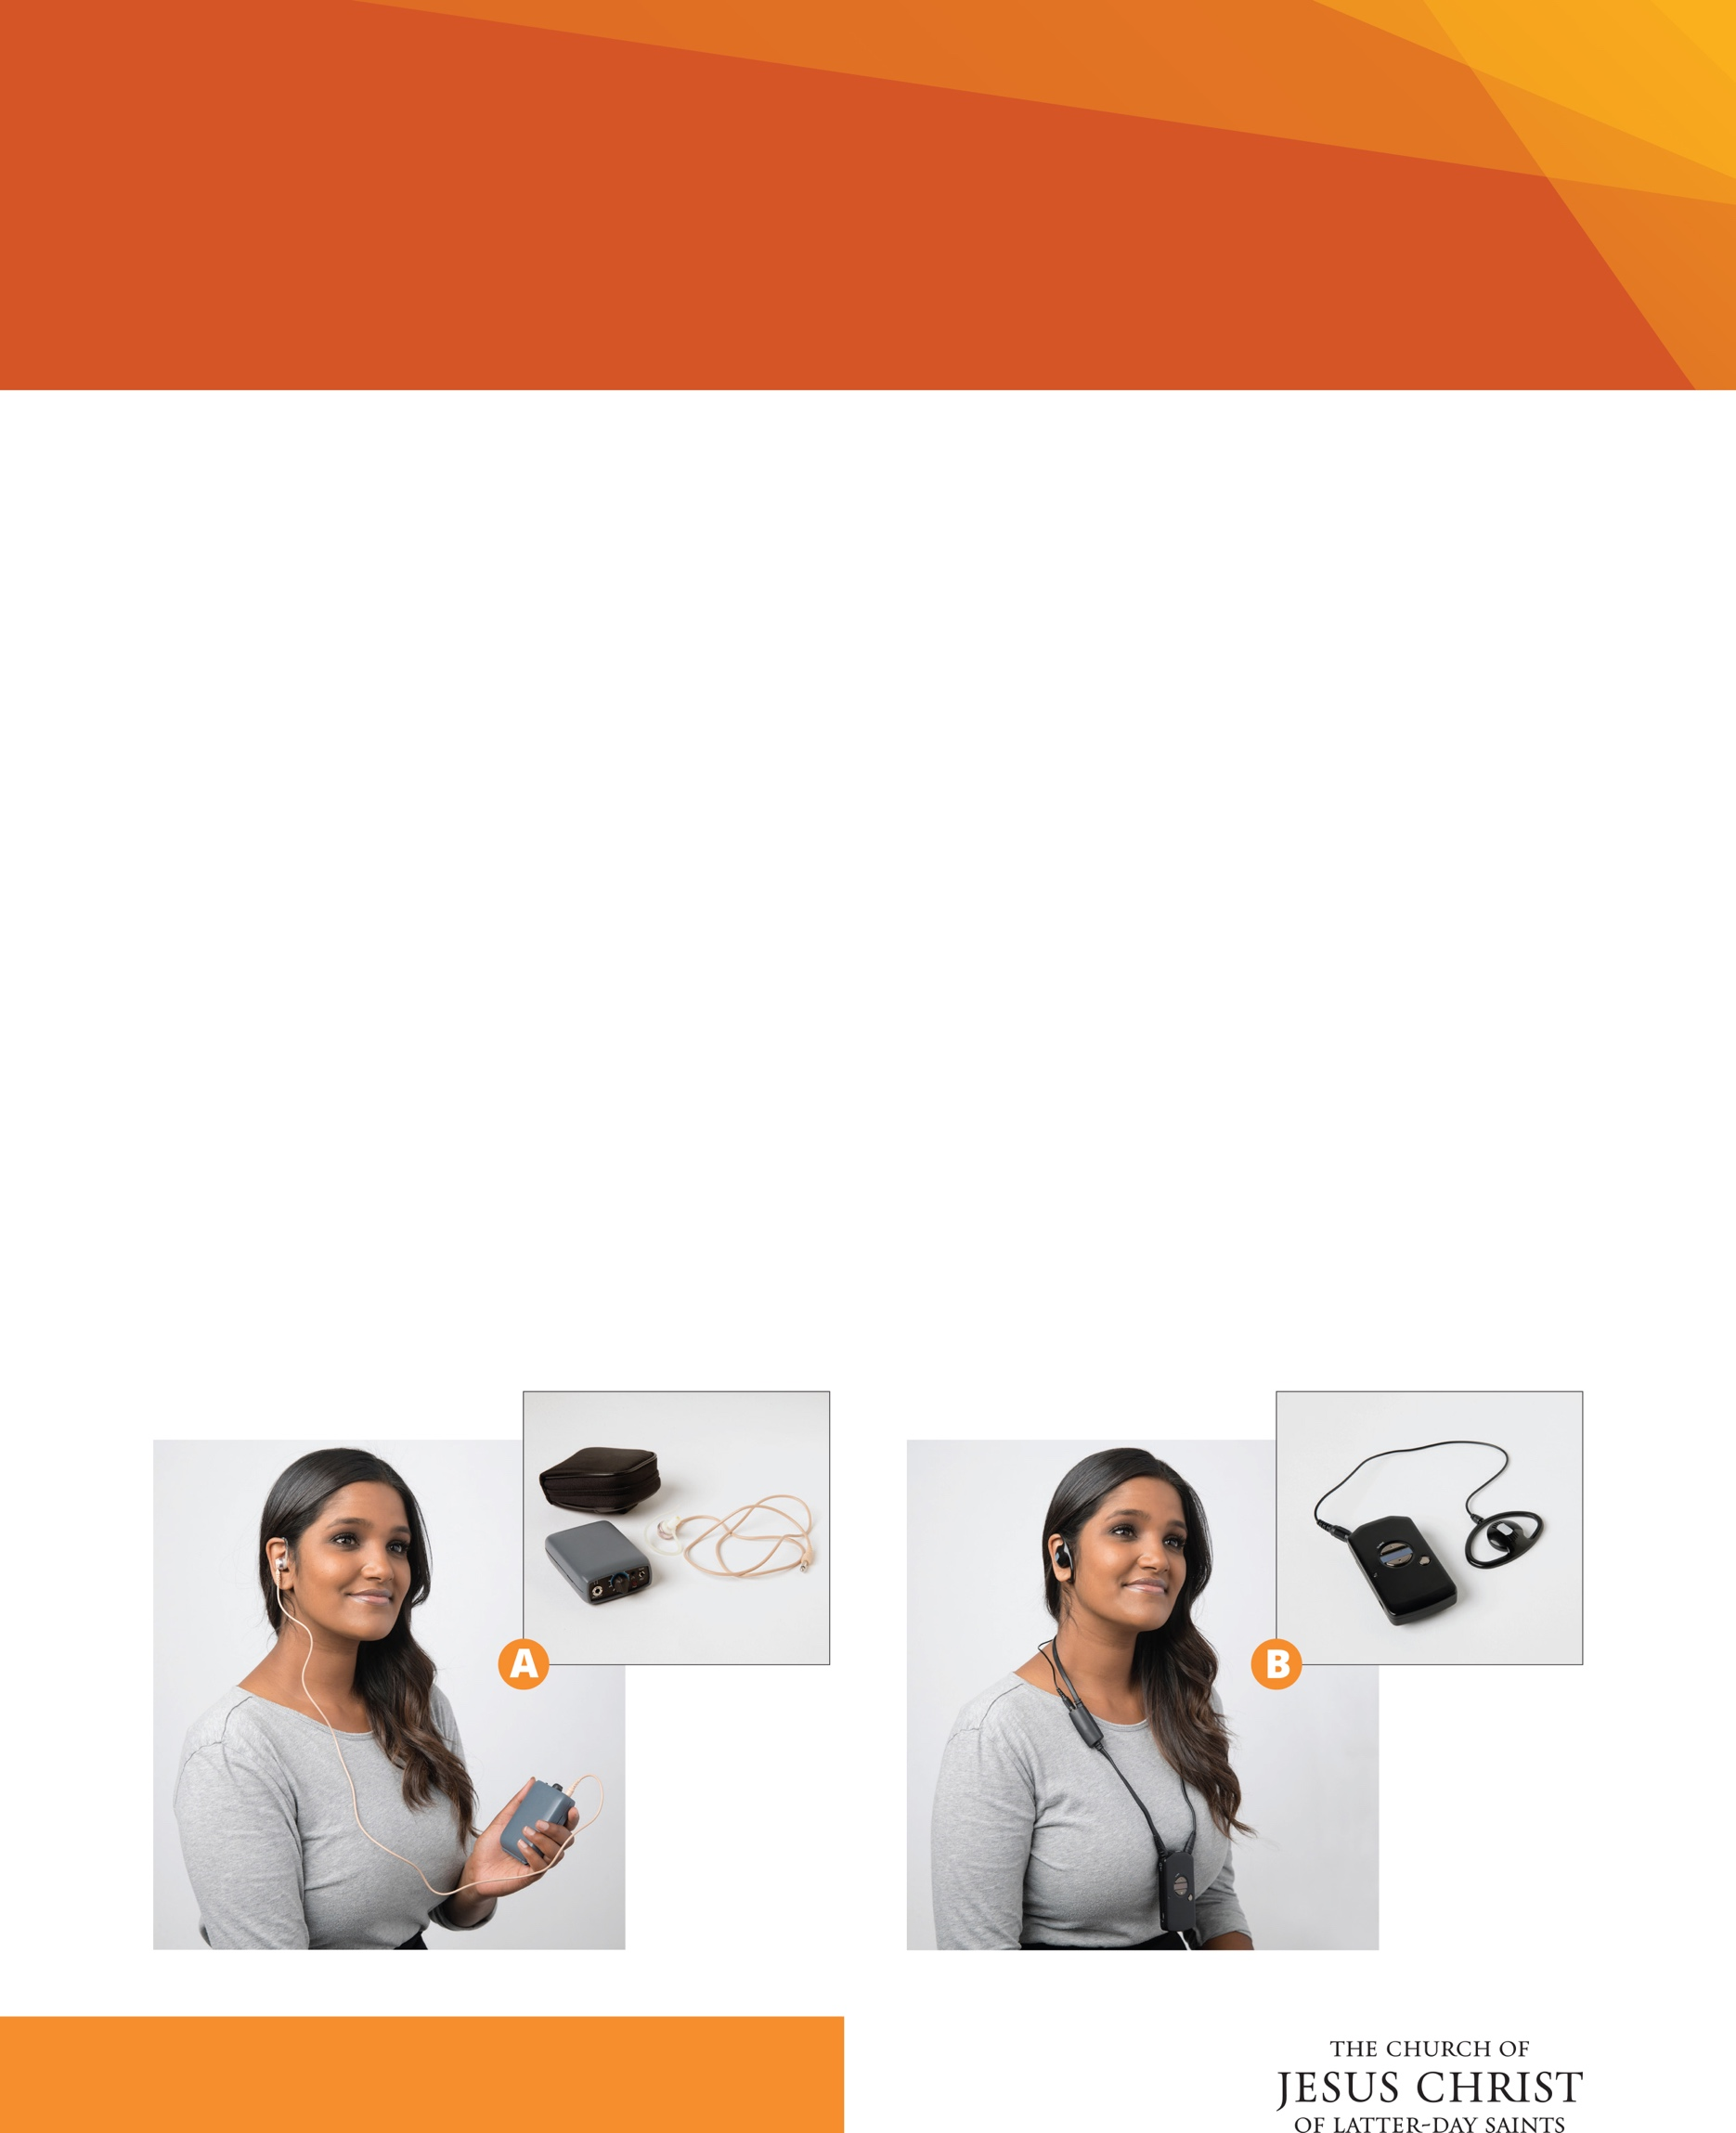

*For more information about ways to support members with disabilities please visit: disability.ChurchofJesusChrist.org*

**SYSTEM B**

HOW TO USE: Remove the device from the charging tray to turn on the device. Connect the earpiece to the device and give it to the user. They will push the button located on the front to select channel.

LOOP SYSTEM: This system can be used on its own or with a loop system. The loop system works with a t-coil enabled hearing aid instead of an earpiece. Disconnect the earpiece from the neck cord and the individual will need to turn on t-coil mode on their hearing aide.

HOW TO CARE FOR: The device should be stored in the charging tray when not in use. This will turn the device off. Earpieces should be cleaned after each use.

The Church provides an assisted listening system in almost every meetinghouse. The listening devices are designed to help individuals who are hard of hearing hear what is being said during church. The devices are to be well maintained and readily available for use by anyone in attendance.

Assisted Listening System

**SYSTEM A**

HOW TO USE: Connect the earpiece to the device. This will turn the unit on. Press the red button on top to scan for channels. Adjust the volume.

LOOP SYSTEM: This system can be used on its own or with a loop system. The loop system works with a t-coil enabled hearing aid instead of an earpiece. This requires an added cord to hang around the neck. The loop system is limited for this model. If you would like to have these available, please contact the facilities manager for your building.

HOW TO CARE FOR: Batteries should be checked and replaced periodically. This device requires two AA batteries. When storing, disconnect the earpiece to turn the device off. Earpieces should be cleaned after each use.

©2019 by Intellectual Reserve Inc. All rights reserved. Printed in the USA. PD60009151